

**A.I. CHAT BOT**

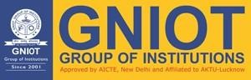

# Department of Computer Science

|  |  |
| --- | --- |
| **Student Name**    Manas Baranwal (1901320310047) | **Project Supervisor/Guide Name:**    Dr. Preety Dhaka |

# Greater Noida Institute of Technology, Greater Noida

Dr. A.P.J. Abdul Kalam Technical University, Lucknow

August, 2022

## INDEX

DECLARATION…………………………………………………………………………………………….

ACKNOWLEDGEMENT………………………………………………………………………………….

ABSTRACT…………………………………………………………………………………………………

INTRODUCTION………………………………………………………………………………………….

OBJECTIVE …………………………………………………………………………………. …………….

METHODOLOGY…………………………………………………………………………………………

TECHNOLOGIES USED……………………………………………………………………………………

SYSTEM REQUIREMENTS………………………………………………………………………………

CONCLUSION………………………………………………………………………………………………

REFERENCES………………………………………………………………………………

### DECLARATION

I hereby declare that the project work entitled “Chit Chat Bot” submitted to the GNIOT Greater Noida, is a record of an original work done by **Manas Baranwal** under the guidance of **Dr. Preety Dhaka,** Project Coordinator of Computer Science, Greater Noida Institute of Technology, Greater Noida and this project work is submitted in the partial fulfillment of the requirements for the award of the degree of Bachelor of Technology in Information Technology. The results embodied in this thesis have not been submitted to any other University or Institute for the award of any degree or diploma.

**Date:**14/09/2022 **Manas Baranwal (1901320310047)**

### ACKNOWLEDGEMENT

I want to sincerely thank my project coordinator **Dr. Preety Dhaka,** for his continuous support and encouragement throughout this project. I would also like to extend my thanks to my Head Of department, **Dr. Vijay Shukla** for their time and support. My special thanks to all my mentors for their guidance and valuable suggestions during the course of this project. I would also like to thanks my teammates who work hard with me to complete the project on time. And lastly, I would like to thank my parents for their support at all times.

### 

### ABSTRACT

One of the goals of artificial intelligence (AI) is the realization of the natural dialogue between the humans and the machines. One such creation is the virtual assistant. It has now become a boon for everyone in the 21st century. The improvement has gone up to the capabilities of becoming a personal companion to humans. Here, introducing a companion namely “A.I. CHAT BOT” which will be different in a way to another one’s as it is holding the capacity to work in offline mode as well.

In this work, I will develop a bot for better interactions even in offline mode with the humans which will be responding you with the desired responses. Currently it is using the data feuded and responses us in that way only, seeking towards its futuristic goals we can enhance its responses by working a lot more on data.

### INTRODUCTION

The goal of the project is to increase the interaction and communication between the machine and the human even without availability of being connected to networks. This software uses the technology known as Natural Language Processing for processing the natural voice input given by the user to the system. The task's features are extracted from the voice input and accordingly it is going to response. Also, these virtual devices are evolving rapidly with their working system and efficiency of the system. But as we may have seen that almost all such personal bots require internet connectivity for their usage. These systems have a huge size of datasets due to which they cannot be stored offline, hence it requires online storage like cloud services. Hence the software is implemented to provide the system i.e., software as well as hardware functionalities accessible by the user through voice commands and without the use of internet connectivity.

.

### OBJECTIVE

The term “chatbot’’ is sometimes used to refer to virtual assistants or specifically accessed by online chat. Virtual personal assistants are typically cloud-based programs that require internet-connected devices but to perform it in simpler way, our main focus is to make a chatbot which response to user without using internet connectivity i.e., chatbot in offline mode. In some cases, chat programs are exclusively for entertainment purposes and mental health-related issues among the population in the (post) pandemic world. These are smart conversational agents that have supported marketing, sales, customer satisfaction activities and public services. Chatbots as extenders of public health services, play a significant role in addressing mental health problems such as loneliness/social isolation because of that imposed quarantine.

**METHODOLOGY**

The CHIT CHAT BOT uses the Natural Language Processing algorithm. The most important function of the system is to work offline i.e., without using the internet connectivity. This software will we helpful for the user who have Health Related Issue of loneliness/social isolation because of that imposed quarantine.

The system basically works in 4 phases:

* Speech Input
* Speech Preprocessing
* Fetch Responses from Database
* Text To Speech

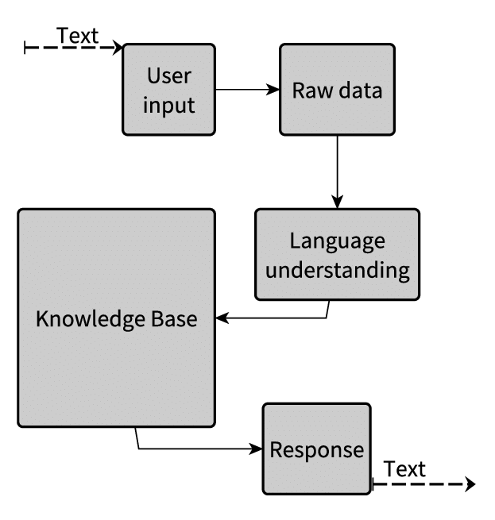

**TECHNOLOGIES USED**

1. Python
2. Speech Recognition System
3. Chatbot
4. Text to Speech

**SYSTEM REQUIREMENTS**

**Hardware Requirements:**

* Windows 7 or above Operating System.
* Minimum 4GB of RAM
* Minimum Intel i3
* Minimum 2GB of Hard disk Space

**Software Requirements:**

* Python3
* Visual Studio Code

**CONCLUSION**

On studying the various applications which are already available in the market, I had seen that almost every application works with internet connectivity. Also, some of them are not very efficient with speech recognition. The A.I. CHAT BOT which is implemented provides the usage of the application without internet connectivity. The user can use the application which can help him/her to remove their loneliness/social isolation because of that imposed quarantine and this will help user in improving their Mental health.

**REFERENCES**

Nadja Damij and Suman Bhattacharya, “The Role of AI Chatbots in Mental Health Related Public Services in a (Post) Pandemic World: A Review and Future Research Agenda”, 2022 IEEE.

The paper describes about the Mental health related issues among the population in the (post)pandemic world have been recognized to be one of the critical areas of concern for public health. Ai-based chatbots are the smart conversational agents that have supported marketing, sales and customer satisfaction activities in various industries for several decades. Such technology-based solutions, especially chatbots as extenders of public health services, which will play a significant role in addressing mental health problems such as loneliness/social isolation.